Business Studies – Key Stage 3
Intent:
Key Stage 3 – Year 9
Intent:
We study Business to develop an awareness and natural curiosity of the business environment around them. To have a deeper understanding of the businesses that students will work for or run, and the key driving factors and inhibitors that impact the environment. Students learn how to manage their current and future financial capabilities in the short, medium and long term. GCSE Business Studies allows students to understand the external influences that dictate whether a business succeeds or fails, such as, political, economic, financial or environmental issues and are encouraged to look beyond the classroom, putting themselves in the shoes of an entrepreneur looking for the next big business opportunity.
The aims of the business department are:
- To introduce students to the dynamics of how a business is set up and organised.
- To enable individuals to enhance their ability to enter the world of work within a wide range of business organisations.
- To develop an understanding of the real world nature of the subject.
To help all students develop an awareness of the impact of the business world.
The pre-option course allows students to explore and develop their enterprising minds. The course will be structured around project-based learning and will include elements such as:
- Marketing and branding
- Finance
- How to set up a business
- Recruitment
The final unit will include the opportunity to run their own small enterprise activity in school.
Implementation:
In year 9, students will have two lessons a week. They will look at key details when starting up a business through projects and research. This will lead to the end of the year where the students will start their own enterprise and use the knowledge they have learned over the course of the year

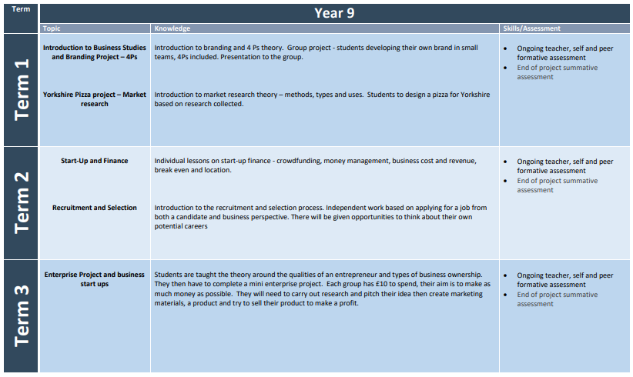

Business Studies – Key Stage 4
Intent:
Key Stage 4
Intent:
We study Business to develop an awareness and natural curiosity of the Business environment around them. To have a deeper understanding of the businesses that students will work for or run, and the key driving factors and inhibitors that impact the environment. Students learn how to manage their current and future financial capability in the short, medium and long term. GCSE Business Studies allows students to understand the external influences that dictate whether a business succeeds or fails, such as, political, economic, financial or environmental issues and are encouraged to look beyond the classroom, putting themselves in the shoes of an entrepreneur looking for the next big business opportunity.
The aims of the business department are:
- To introduce students to the dynamics of how a business is set up and organised.
- To enable individuals to enhance their ability to enter the world of work within a wide range of business organisations.
- To develop an understanding of the real world nature of the subject.
- To help all students develop an awareness of the impact of the business world.
This is a one year course focusing on both the theoretical and practical aspects of establishing and running a business. GCSE Business Studies allows students to understand the external influences that dictate whether a business succeeds or fails, such as, political, economic, financial or environmental issues. Students are encouraged to look beyond the classroom, putting themselves in the shoes of an entrepreneur looking for the next big business opportunity.
Paper 1 – Investigating Small Businesses (50%): Topics such as enterprise and entrepreneurship, spotting a business opportunity, putting a business idea into practice, making the business effective, and understanding external influences on business.
- Paper 2 – Building A Business (50%): Topics such as growing the business, making marketing, operational, financial and human resource decisions.
Implementation:
For KS4, students will start the year looking at theme 1. This focuses on starting up businesses and small businesses. After looking at this content, students will then explore larger enterprises, and the factors needed to maintain the businesses.



