**Spring 2023**

**Future dates for your diary:**

**20 – 24 February 2023**  
Y11 Mock Exams

**27 February – 3 March 2023**  
Y11 Mock Exams  
(plus Y10 Option Subjects)

**2 March 2023**  
Y9 Parents Evening

**6 March – 10 March 2023**  
Y11 French Speaking Tests

**7 March 2023**  
Book Fair

**16 March 2023**  
Y10 Parents Evening

**22 – 24 March 2023**  
Y11 Food Practical Exams

**23 March 2023**  
Y10 Parents/Exam Preparation Evening

**30 March 2023**  
Y11 Exam Preparation Evening

**Welcome from Principal Diana Townshend**

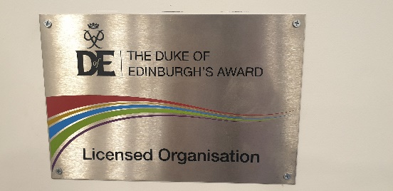

**We are very excited to have launched  
The Duke of Edinburgh’s Award for our  
Year 9 and 10…so many opportunities coming for our young people!**

Welcome to our new Featherstone Newsletter. In it we will keep you up to date with what has been happening in school, and celebrate the achievements of our young people. We hope that you enjoy our first edition.

January blues have been banished this year with further refurbishment of the school building; you may have noticed our new-look reception. Throughout the school we have had brand new doors, and the library is undergoing a refit due to a £10,000 investment from the Rodillian Multi Academy Trust. We will also be purchasing new canteen furniture in order to introduce a more modern café-culture experience for our young people.

At this time of the year when the days are short and dark, it can be difficult to find motivation, however our Year 8 and Year 9 students shine in our innovative Applied Resilience where they learn and practise a new skill in an area that they choose. They show their enthusiasm and resilience each week as they apply their Growth Mindsets. We are delighted that we are supported by our fantastic partners the Featherstone Rovers. We are big fans! We are growing our own computer coders, sports leaders, dancers, singers, artists, future Bake-Off and Sewing-Bee contestants as well as our sports stars of the future with our Rugby and Netball Academies. Life at The Featherstone Academy is full of extra opportunities.

**@FeatherstoneAca**

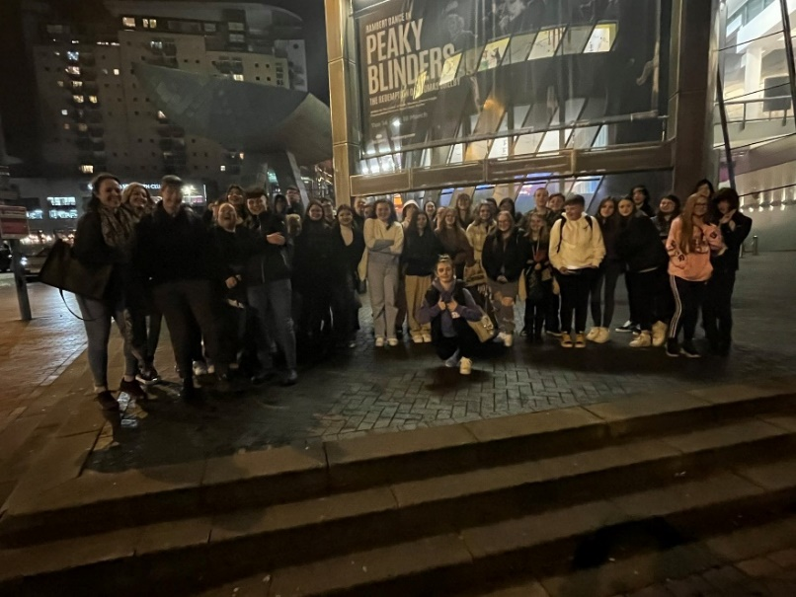

**Key Stage 4  
Revision Conferences**

Over the last term, our Key Stage 4 students have taken part in a series of Revision Conferences which have been designed to support students with evidence-based revision strategies to support them in their examinations.

Students have had sessions which focus on how their brain works and how they need to move knowledge from their working memory to long term memories, in order to recall them quickly and accurately.

We looked together at a range of strategies they could use such as; Cornell note taking, flash cards for key words/phrases/quotes and how to use technology as a tool for revision.

The active sessions saw a range of subject leaders modelling the strategies and supporting students with attempting the revision together.

The conferences were well received with students commenting on how they will use the methods in their own practice as they head into the exam period.

**‘An Inspector Calls’ trip to Manchester for Years 10 and 11**

The English department took a group of KS4 students (and a few eager Year 9s!) to Salford's Lowry Theatre to see a performance of J.B. Priestley's 'An Inspector Calls'.

After an evening coach trip down the M62, we arrived at the Lowry Theatre in Salford. All of us, staff and students alike, were excited to spot the sights of Media City and see the dazzling glass structures of the quayside. Our students loved the buzz and excitement of the pre-theatre atmosphere as the foyer was packed full of schools and families ready to see this excellent show.

The show itself was brilliant. It brought to life the text our students have studied and provoked intense discussion about our own differing interpretations of the characters and the story. The staging was incredibly clever and we were amazed at the intricacy and beauty of the stagecraft (and shocked by some pre-planned explosions!).

Our students were a credit to our school and to yourselves, behaving with impeccable manners and respect throughout the whole experience. We were hugely proud to accompany them to the theatre and can't wait to do it again!

It was a late night as we did not get back to the academy until 11pm but it was certainly worth it...!

Thank you for all of your support for the trip and thanks to Ms. Townshend, Mr Ledda, Ms Schofield and Ms Ballance for accompanying us to Salford.

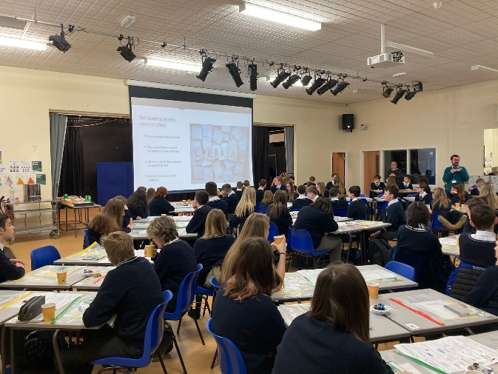



**www.featherstone.academy**

**Sport Round-Up**



Year 8 Rugby Academy team recently played their first game of Rugby Union against a strong team from The King’s High School, losing 20-5. The boys fought well until the end after a nervy start, going 15-0 down at half time. The team performed some excellent try saving tackles, as well as forcing errors from their opponents to provide tough competition in the 2nd half. The Year 9 team travelled to Brayton Academy on Wednesday 8 February and put into practice the excellent work they've done in their Applied Resilience sessions – they won 47–9!

The Year 7 football team will be travelling to Outwood Academy Freeston on Thursday 9 February to continue their cup run, hoping to progress into the semi finals!

Recently, the Year 8/9 Netball Academy Team played host to a fixture against Outwood Academy City Fields Year 9 team. A close game with our pupils working hard and performing brilliantly, 'Believing in their best'- hungry for the win!! The games finished with a 4-3 victory!!

Huge congratulations to all students!

**France here we come!**

Following a three-year hiatus due to the pandemic, the Rodillian Multi Academy Trust are excited to announce the return of Resilience Camp France for 2023. Set in the Ardèche region in southeast France, Resilience Camp France has been operating within the Trust for almost a decade. Year 7 students will develop their teamwork and communication skills, as well as experience activities in the outdoors, including kayaking, mountain biking and a high ropes course, alongside cultural visits local to markets and towns. The seven-night trip will take place in June 2023 and will include return flights and transfers from the Academy to France, full board, insurance and expert-guided instruction for all activities. All students will be camping during the week at a campsite near the village of Vagnas. Tents and sleeping bags will be provided by the Trust, and on the campsite, there is a swimming pool, table tennis, football, rugby, basketball and volleyball facilities, and a games arcade.

We are very much looking forward to the trip. The countdown is on...

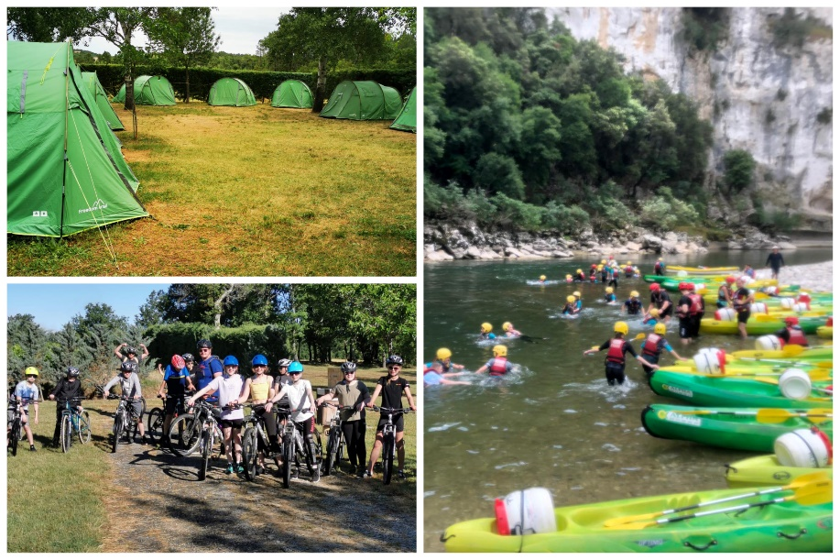



**info@featherstone.academy**



**Attendance matters**



**Our top attenders**

* Ruby A-L, Year 7
* Christopher B, Year 7
* Rosie L, Year 8
* Ellie M, Year 8
* Siena B, Year 9
* Callum A, Year 9
* Francisco A, Year 10
* Libby G, Year 10
* Caleb D, Year 11
* Molly G, Year 11

**Attendance at school is a priority for us.** We want to give all our student’s the best start in life, and we know that education and support from school can help to do this. All students should strive for 100% attendance and 0 lates. Their attendance should not drop below the school target of 98% for each academic year.

Our attendance pyramid shows the impact that attendance can have on your child's progress. Those students that have less than 98% are less likely to achieve their target and ultimately less likely to go on to further education and study something they enjoy. Every lesson counts and every lesson is just another piece to the jigsaw in enabling your child to reach their potential and become the successful adult they can be.

Punctuality is equally as important. Form time is used to ensure students are calm and equipped to be successful during their school day. Year 10 and 11 are expected to be in school for 8.15am and Year 7, 8 and 9 are expected to be in for 8.25am.

**To report a child’s absence please call 01977 722812 before 9:00am on the first and every day of absence.**